Poinsettias for sale!
$15
$15
Support Lovelady One Act Play

The poinsettias for this fundraiser are being purchased from Down Home Ranch located near Elgin, Texas. One of the primary missions of Down Home Ranch, a non-profit, is to provide dignified living and working conditions for its residents with special needs. The residents work in the greenhouses and have a significant role in the planting and care of the plants. We are excited to be able to assist another non-profit through our fall fundraiser.
*Plants are 18-24 inches tall and have 3-5 large blooms on them*

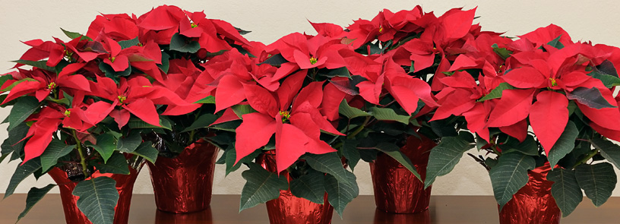
All orders must be in by November 15th
Poinsettias can be picked up Wednesday, November 28th
Place Order Here

Name _______________________________

Phone Number ________________________

Number of Red Poinsettias _____________ ($15 each)

Subtotal: $_________ Check # _________

Cash or checks accepted

Please make checks payable to Lovelady ISD Theatre

in front of Lovelady HS from 3:00-5:00
Student Selling _______________

Contacted on 11/27? __________

